#### Linnea Williams - Course Project, Phase 1

ames_sales <- read_csv("ames_student.csv")

## Warning: Missing column names filled in: 'X1' [1]

##   
## -- Column specification --------------------------------------------------------  
## cols(  
## .default = col_character(),  
## X1 = col_double(),  
## Lot_Frontage = col_double(),  
## Lot_Area = col_double(),  
## Year_Built = col_double(),  
## Year_Remod_Add = col_double(),  
## Mas_Vnr_Area = col_double(),  
## BsmtFin_SF_1 = col_double(),  
## BsmtFin_SF_2 = col_double(),  
## Bsmt_Unf_SF = col_double(),  
## Total_Bsmt_SF = col_double(),  
## First_Flr_SF = col_double(),  
## Second_Flr_SF = col_double(),  
## Low_Qual_Fin_SF = col_double(),  
## Gr_Liv_Area = col_double(),  
## Bsmt_Full_Bath = col_double(),  
## Bsmt_Half_Bath = col_double(),  
## Full_Bath = col_double(),  
## Half_Bath = col_double(),  
## Bedroom_AbvGr = col_double(),  
## Kitchen_AbvGr = col_double()  
## # ... with 15 more columns  
## )  
## i Use `spec()` for the full column specifications.

# str(ames_sales)  
# summary(ames_sales)

ames_sales = ames_sales %>%   
 mutate(  
 Year_Built_Group = case_when(  
 Year_Built <= 1890 ~ "< 1890",  
 Year_Built > 1890 & Year_Built <= 1905 ~ "1891-1905",  
 Year_Built > 1905 & Year_Built <= 1920 ~ "1906-1920",  
 Year_Built > 1920 & Year_Built <= 1935 ~ "1921-1935",  
 Year_Built > 1935 & Year_Built <= 1950 ~ "1936-1950",  
 Year_Built > 1950 & Year_Built <= 1965 ~ "1951-1965",  
 Year_Built > 1965 & Year_Built <= 1980 ~ "1966-1980",  
 Year_Built > 1980 & Year_Built <= 1995 ~ "1981-1995",  
 Year_Built > 1995 & Year_Built <= 2010 ~ "1996-2010",  
 TRUE ~ "> 2010"  
 )  
 )  
  
ames_sales = ames_sales %>%   
 mutate(  
 Year_RemodAdd_Group = case_when(  
 Year_Remod_Add <= 1950 ~ "< 1950",  
 Year_Remod_Add > 1950 & Year_Remod_Add <= 1960 ~ "1951-1960",  
 Year_Remod_Add > 1960 & Year_Remod_Add <= 1970 ~ "1961-1970",  
 Year_Remod_Add > 1970 & Year_Remod_Add <= 1980 ~ "1971-1980",  
 Year_Remod_Add > 1980 & Year_Remod_Add <= 1990 ~ "1981-1990",  
 Year_Remod_Add > 1990 & Year_Remod_Add <= 2000 ~ "1991-2000",  
 Year_Remod_Add > 2000 & Year_Remod_Add <= 2010 ~ "2000-2010",  
 TRUE ~ "> 2010"  
 )  
 )  
  
# glimpse(ames_sales)

ames_sales <- ames_sales %>% mutate_if(is.character, as.factor)  
  
# glimpse(ames_sales)

# levels(ames_sales$Lot_Shape)  
# levels(ames_sales$Utilities)  
# levels(ames_sales$Land_Slope)  
# levels(ames_sales$Overall_Qual)  
# levels(ames_sales$Overall_Cond)  
# levels(ames_sales$Exter_Qual)  
# levels(ames_sales$Exter_Cond)  
# levels(ames_sales$Bsmt_Qual)  
# levels(ames_sales$Bsmt_Cond)  
# levels(ames_sales$Bsmt_Exposure)  
# levels(ames_sales$BsmtFin_Type_1)  
# levels(ames_sales$BsmtFin_Type_2)  
# levels(ames_sales$Heating_QC)  
# levels(ames_sales$Electrical)  
# levels(ames_sales$Kitchen_Qual)  
# levels(ames_sales$Functional)  
# levels(ames_sales$Fireplace_Qu)  
# levels(ames_sales$Garage_Finish)  
# levels(ames_sales$Garage_Qual)  
# levels(ames_sales$Garage_Cond)  
# levels(ames_sales$Paved_Drive)  
# levels(ames_sales$Pool_QC)  
# levels(ames_sales$Fence)  
#levels(ames_sales$Year_Built_Group)  
#levels(ames_sales$Year_RemodAdd_Group)

ames_sales$Lot_Shape <-factor(ames_sales$Lot_Shape,levels(ames_sales$Lot_Shape)  
 [c(3,4,2,1)])  
levels(ames_sales$Lot_Shape)

## [1] "Regular" "Slightly_Irregular" "Moderately_Irregular"  
## [4] "Irregular"

ames_sales$Overall_Qual<-factor(ames_sales$Overall_Qual,  
 levels(ames_sales$Overall_Qual)  
 [c(8,4,9,6,1,2,3,5,7,10)])  
levels(ames_sales$Overall_Qual)

## [1] "Very_Excellent" "Excellent" "Very_Good" "Good"   
## [5] "Above_Average" "Average" "Below_Average" "Fair"   
## [9] "Poor" "Very_Poor"

ames_sales$Overall_Cond<-factor(ames_sales$Overall_Cond,  
 levels(ames_sales$Overall_Cond)  
 [c(10,4,8,6,1,2,3,5,7,9)])  
levels(ames_sales$Overall_Cond)

## [1] "Excellent" "Very_Good" "Good" "Above_Average"  
## [5] "Average" "Below_Average" "Fair" "Poor"   
## [9] "Very_Poor"

#Note to self - this data set does not have a "Very Excellent" Overall_Cond, revisit this on competition data set  
  
ames_sales$Exter_Qual<-factor(ames_sales$Exter_Qual,  
 levels(ames_sales$Exter_Qual)[c(1,3,4,2,5)])  
levels(ames_sales$Exter_Qual)

## [1] "Excellent" "Good" "Typical" "Fair"

#Note to self - this data set does not have a "Poor" Exter_Qual, revisit this on competition data set  
  
ames_sales$Exter_Cond <-factor(ames_sales$Exter_Cond,  
 levels(ames_sales$Exter_Cond)[c(1,3,5,2,4)])  
levels(ames_sales$Exter_Cond)

## [1] "Excellent" "Good" "Typical" "Fair" "Poor"

ames_sales$Bsmt_Qual <-factor(ames_sales$Bsmt_Qual,  
 levels(ames_sales$Bsmt_Qual)[c(1,3,6,2,5,4)])  
levels(ames_sales$Bsmt_Qual)

## [1] "Excellent" "Good" "Typical" "Fair" "Poor"   
## [6] "No_Basement"

ames_sales$Bsmt_Cond <-factor(ames_sales$Bsmt_Cond,  
 levels(ames_sales$Bsmt_Cond)[c(1,3,6,2,5,4)])  
levels(ames_sales$Bsmt_Cond)

## [1] "Excellent" "Good" "Typical" "Fair" "Poor"   
## [6] "No_Basement"

ames_sales$Bsmt_Exposure <-factor(ames_sales$Bsmt_Exposure,  
 levels(ames_sales$Bsmt_Exposure)[c(2,1,3,4,5)])  
levels(ames_sales$Bsmt_Exposure)

## [1] "Gd" "Av" "Mn" "No" "No_Basement"

ames_sales$BsmtFin_Type_1 <-factor(ames_sales$BsmtFin_Type_1,  
 levels(ames_sales$BsmtFin_Type_1)  
 [c(3,1,2,6,4,7,5)])  
levels(ames_sales$BsmtFin_Type_1)

## [1] "GLQ" "ALQ" "BLQ" "Rec" "LwQ"   
## [6] "Unf" "No_Basement"

ames_sales$BsmtFin_Type_2 <-factor(ames_sales$BsmtFin_Type_2,  
 levels(ames_sales$BsmtFin_Type_2)  
 [c(3,1,2,6,4,7,5)])  
levels(ames_sales$BsmtFin_Type_2)

## [1] "GLQ" "ALQ" "BLQ" "Rec" "LwQ"   
## [6] "Unf" "No_Basement"

ames_sales$Heating_QC <-factor(ames_sales$Heating_QC,  
 levels(ames_sales$Heating_QC)[c(1,3,5,2,4)])  
levels(ames_sales$Heating_QC)

## [1] "Excellent" "Good" "Typical" "Fair" "Poor"

ames_sales$Electrical <-factor(ames_sales$Electrical,  
 levels(ames_sales$Electrical)[c(4,1,2,3,5)])  
levels(ames_sales$Electrical)

## [1] "SBrkr" "FuseA" "FuseF" "FuseP" "Unknown"

ames_sales$Kitchen_Qual <-factor(ames_sales$Kitchen_Qual,  
 levels(ames_sales$Kitchen_Qual)[c(1,3,5,2,4)])  
levels(ames_sales$Kitchen_Qual)

## [1] "Excellent" "Good" "Typical" "Fair" "Poor"

ames_sales$Functional <-factor(ames_sales$Functional,  
 levels(ames_sales$Functional)  
 [c(8,3,4,5,1,2,7,6)])  
levels(ames_sales$Functional)

## [1] "Typ" "Min1" "Min2" "Mod" "Maj1" "Maj2" "Sev" "Sal"

ames_sales$Fireplace_Qu <-factor(ames_sales$Fireplace_Qu,  
 levels(ames_sales$Fireplace_Qu)[c(1,3,6,2,5,4)])  
levels(ames_sales$Fireplace_Qu)

## [1] "Excellent" "Good" "Typical" "Fair" "Poor"   
## [6] "No_Fireplace"

ames_sales$Garage_Finish <-factor(ames_sales$Garage_Finish,  
 levels(ames_sales$Garage_Finish)  
 [c(1,3,4,2)])  
levels(ames_sales$Garage_Finish)

## [1] "Fin" "RFn" "Unf" "No_Garage"

ames_sales$Garage_Qual <-factor(ames_sales$Garage_Qual,  
 levels(ames_sales$Garage_Qual)[c(1,3,6,2,5,4)])  
levels(ames_sales$Garage_Qual)

## [1] "Excellent" "Good" "Typical" "Fair" "Poor" "No_Garage"

ames_sales$Garage_Cond <-factor(ames_sales$Garage_Cond,  
 levels(ames_sales$Garage_Cond)[c(1,3,6,2,5,4)])  
levels(ames_sales$Garage_Cond)

## [1] "Excellent" "Good" "Typical" "Fair" "Poor" "No_Garage"

ames_sales$Paved_Drive <-factor(ames_sales$Paved_Drive,  
 levels(ames_sales$Paved_Drive)[c(3,2,1)])  
levels(ames_sales$Paved_Drive)

## [1] "Paved" "Partial_Pavement" "Dirt_Gravel"

ames_sales$Pool_QC <-factor(ames_sales$Pool_QC,  
 levels(ames_sales$Pool_QC)[c(1,3,5,2,4)])  
levels(ames_sales$Pool_QC)

## [1] "Excellent" "Good" "Typical" "Fair" "No_Pool"

ames_sales$Fence <-factor(ames_sales$Fence,levels(ames_sales$Fence)  
 [c(1,3,2,4,5)])  
levels(ames_sales$Fence)

## [1] "Good_Privacy" "Minimum_Privacy" "Good_Wood"   
## [4] "Minimum_Wood_Wire" "No_Fence"

levels(ames_sales$Neighborhood)

## [1] "Bloomington_Heights"   
## [2] "Blueste"   
## [3] "Briardale"   
## [4] "Brookside"   
## [5] "Clear_Creek"   
## [6] "College_Creek"   
## [7] "Crawford"   
## [8] "Edwards"   
## [9] "Gilbert"   
## [10] "Green_Hills"   
## [11] "Greens"   
## [12] "Iowa_DOT_and_Rail_Road"   
## [13] "Landmark"   
## [14] "Meadow_Village"   
## [15] "Mitchell"   
## [16] "North_Ames"   
## [17] "Northpark_Villa"   
## [18] "Northridge"   
## [19] "Northridge_Heights"   
## [20] "Northwest_Ames"   
## [21] "Old_Town"   
## [22] "Sawyer"   
## [23] "Sawyer_West"   
## [24] "Somerset"   
## [25] "South_and_West_of_Iowa_State_University"  
## [26] "Stone_Brook"   
## [27] "Timberland"   
## [28] "Veenker"

# Had a duplicate Overall_Qual code that wrote over the first code, now to fix again  
  
# ames_sales$Overall_Qual<-factor(ames_sales$Overall_Qual,  
# levels(ames_sales$Overall_Qual)  
# [c(5,6,7,2,8,4,9,1,3,10)])  
levels(ames_sales$Overall_Qual)

## [1] "Very_Excellent" "Excellent" "Very_Good" "Good"   
## [5] "Above_Average" "Average" "Below_Average" "Fair"   
## [9] "Poor" "Very_Poor"

ames_sales <- ames_sales %>%   
 mutate(Bsmt_Full_Bath = as_factor(Bsmt_Full_Bath)) %>%   
 mutate(Bsmt_Half_Bath = as_factor(Bsmt_Half_Bath)) %>%   
 mutate(Full_Bath = as_factor(Full_Bath)) %>%   
 mutate(Half_Bath = as_factor(Half_Bath)) %>%   
 mutate(Bedroom_AbvGr = as_factor(Bedroom_AbvGr)) %>%   
 mutate(Kitchen_AbvGr = as_factor(Kitchen_AbvGr)) %>%   
 mutate(TotRms_AbvGrd = as_factor(TotRms_AbvGrd)) %>%   
 mutate(Fireplaces = as_factor(Fireplaces)) %>%   
 mutate(Garage_Cars = as_factor(Garage_Cars))%>%  
   
 mutate(Mo_Sold = as_factor(Mo_Sold)) %>%   
 mutate(Year_Sold = as_factor(Year_Sold))   
  
#glimpse(ames_sales)

ames_sales = ames_sales %>%   
 mutate(Land_Slope = fct_recode(Land_Slope, "Gentle" = "Gtl",   
 "Moderate" = "Mod", "Severe" = "Sev" )) %>%  
 mutate(Bsmt_Exposure = fct_recode(Bsmt_Exposure, "Good" = "Gd",   
 "Average" = "Av", "Minimum" = "Mn",   
 "No Exposure" = "No",   
 "No Basement" = "NA" )) %>%  
 mutate(BsmtFin_Type_1 = fct_recode(BsmtFin_Type_1, "Good Living" = "GLQ",   
 "Avg Living" = "ALQ",   
 "Below Avg Living" ="BLQ",   
 "Avg Rec" = "Rec",   
 "Low Quality" = "LwQ",  
 "Unfinished" = "Unf", "No Basement" = "NA"))%>%  
 mutate(BsmtFin_Type_2 = fct_recode(BsmtFin_Type_2, "Good Living" = "GLQ",   
 "Avg Living" = "ALQ",   
 "Below Avg Living" ="BLQ",   
 "Avg Rec" = "Rec",   
 "Low Quality" = "LwQ",  
 "Unfinished" = "Unf", "No Basement" = "NA"))%>%  
 mutate(Central_Air = fct_recode(Central_Air, "Yes" = "Y",   
 "No" = "N")) %>%  
 mutate(Garage_Finish = fct_recode(Garage_Finish, "Finished" = "Fin",   
 "Rough Finished" = "RFn",   
 "Unfinished" = "Unf", "No Garge" = "NA"))

## Warning: Unknown levels in `f`: NA  
  
## Warning: Unknown levels in `f`: NA  
  
## Warning: Unknown levels in `f`: NA  
  
## Warning: Unknown levels in `f`: NA

ames_sales = ames_sales %>%   
 mutate(Neighborhood = fct_recode(Neighborhood, "S and W of ISU" =   
 "South_and_West_of_Iowa_State_University")  
 )  
  
  
levels(ames_sales$Garage_Finish)

## [1] "Finished" "Rough Finished" "Unfinished" "No_Garage"

#glimpse(ames_sales)

skim(ames_sales)

Data summary

|  |  |
| --- | --- |
| Name | ames_sales |
| Number of rows | 2053 |
| Number of columns | 84 |
| _______________________ |  |
| Column type frequency: |  |
| factor | 60 |
| numeric | 24 |
| ________________________ |  |
| Group variables | None |

**Variable type: factor**

|  |  |  |  |  |  |
| --- | --- | --- | --- | --- | --- |
| skim_variable | n_missing | complete_rate | ordered | n_unique | top_counts |
| MS_SubClass | 0 | 1 | FALSE | 16 | One: 772, Two: 383, One: 204, One: 129 |
| MS_Zoning | 0 | 1 | FALSE | 7 | Res: 1600, Res: 326, Flo: 87, Res: 20 |
| Street | 0 | 1 | FALSE | 2 | Pav: 2046, Grv: 7 |
| Alley | 0 | 1 | FALSE | 3 | No_: 1914, Gra: 94, Pav: 45 |
| Lot_Shape | 0 | 1 | FALSE | 4 | Reg: 1275, Sli: 714, Mod: 53, Irr: 11 |
| Land_Contour | 0 | 1 | FALSE | 4 | Lvl: 1833, HLS: 94, Bnk: 81, Low: 45 |
| Utilities | 0 | 1 | FALSE | 2 | All: 2052, NoS: 1 |
| Lot_Config | 0 | 1 | FALSE | 5 | Ins: 1495, Cor: 359, Cul: 135, FR2: 56 |
| Land_Slope | 0 | 1 | FALSE | 3 | Gen: 1951, Mod: 89, Sev: 13 |
| Neighborhood | 0 | 1 | FALSE | 28 | Nor: 327, Col: 183, Old: 181, Edw: 129 |
| Condition_1 | 0 | 1 | FALSE | 9 | Nor: 1771, Fee: 113, Art: 67, RRA: 35 |
| Condition_2 | 0 | 1 | FALSE | 8 | Nor: 2027, Fee: 12, Art: 4, Pos: 4 |
| Bldg_Type | 0 | 1 | FALSE | 5 | One: 1706, Twn: 157, Dup: 76, Twn: 67 |
| House_Style | 0 | 1 | FALSE | 8 | One: 1052, Two: 590, One: 225, SLv: 90 |
| Overall_Qual | 0 | 1 | FALSE | 10 | Ave: 587, Abo: 518, Goo: 411, Ver: 237 |
| Overall_Cond | 0 | 1 | FALSE | 9 | Ave: 1143, Abo: 376, Goo: 286, Ver: 98 |
| Roof_Style | 0 | 1 | FALSE | 6 | Gab: 1607, Hip: 404, Fla: 14, Gam: 14 |
| Roof_Matl | 0 | 1 | FALSE | 6 | Com: 2023, Tar: 17, WdS: 8, WdS: 3 |
| Exterior_1st | 0 | 1 | FALSE | 16 | Vin: 705, Met: 319, Wd : 313, HdB: 303 |
| Exterior_2nd | 0 | 1 | FALSE | 17 | Vin: 699, Met: 317, Wd : 302, HdB: 277 |
| Mas_Vnr_Type | 0 | 1 | FALSE | 5 | Non: 1231, Brk: 638, Sto: 166, Brk: 17 |
| Exter_Qual | 0 | 1 | FALSE | 4 | Typ: 1272, Goo: 682, Exc: 78, Fai: 21 |
| Exter_Cond | 0 | 1 | FALSE | 5 | Typ: 1787, Goo: 213, Fai: 43, Exc: 9 |
| Foundation | 0 | 1 | FALSE | 6 | PCo: 911, CBl: 880, Brk: 216, Sla: 36 |
| Bsmt_Qual | 0 | 1 | FALSE | 6 | Typ: 911, Goo: 849, Exc: 178, Fai: 57 |
| Bsmt_Cond | 0 | 1 | FALSE | 6 | Typ: 1833, Goo: 80, Fai: 76, No_: 57 |
| Bsmt_Exposure | 0 | 1 | FALSE | 5 | No : 1331, Ave: 284, Goo: 199, Min: 179 |
| BsmtFin_Type_1 | 0 | 1 | FALSE | 7 | Unf: 602, Goo: 578, Avg: 298, Avg: 216 |
| BsmtFin_Type_2 | 0 | 1 | FALSE | 7 | Unf: 1740, Avg: 79, Low: 64, No_: 58 |
| Heating | 0 | 1 | FALSE | 6 | Gas: 2019, Gas: 21, Gra: 6, Wal: 5 |
| Heating_QC | 0 | 1 | FALSE | 5 | Exc: 1040, Typ: 618, Goo: 333, Fai: 61 |
| Central_Air | 0 | 1 | FALSE | 2 | Yes: 1916, No: 137 |
| Electrical | 0 | 1 | FALSE | 5 | SBr: 1887, Fus: 126, Fus: 33, Fus: 6 |
| Bsmt_Full_Bath | 0 | 1 | FALSE | 4 | 0: 1201, 1: 823, 2: 27, 3: 2 |
| Bsmt_Half_Bath | 0 | 1 | FALSE | 3 | 0: 1936, 1: 115, 2: 2 |
| Full_Bath | 0 | 1 | FALSE | 5 | 2: 1080, 1: 920, 3: 41, 0: 10 |
| Half_Bath | 0 | 1 | FALSE | 3 | 0: 1300, 1: 736, 2: 17 |
| Bedroom_AbvGr | 0 | 1 | FALSE | 7 | 3: 1105, 2: 527, 4: 297, 1: 73 |
| Kitchen_AbvGr | 0 | 1 | FALSE | 3 | 1: 1959, 2: 92, 3: 2 |
| Kitchen_Qual | 0 | 1 | FALSE | 5 | Typ: 1070, Goo: 790, Exc: 142, Fai: 50 |
| TotRms_AbvGrd | 0 | 1 | FALSE | 11 | 6: 589, 7: 468, 5: 416, 8: 245 |
| Functional | 0 | 1 | FALSE | 8 | Typ: 1896, Min: 54, Min: 51, Mod: 27 |
| Fireplaces | 0 | 1 | FALSE | 5 | 0: 993, 1: 891, 2: 161, 3: 7 |
| Fireplace_Qu | 0 | 1 | FALSE | 6 | No_: 993, Goo: 538, Typ: 409, Fai: 56 |
| Garage_Type | 0 | 1 | FALSE | 7 | Att: 1204, Det: 549, Bui: 127, No_: 108 |
| Garage_Finish | 0 | 1 | FALSE | 4 | Unf: 872, Rou: 563, Fin: 509, No_: 109 |
| Garage_Cars | 0 | 1 | FALSE | 6 | 2: 1131, 1: 539, 3: 261, 0: 108 |
| Garage_Qual | 0 | 1 | FALSE | 6 | Typ: 1839, No_: 109, Fai: 85, Goo: 16 |
| Garage_Cond | 0 | 1 | FALSE | 6 | Typ: 1872, No_: 109, Fai: 53, Goo: 10 |
| Paved_Drive | 0 | 1 | FALSE | 3 | Pav: 1848, Dir: 163, Par: 42 |
| Pool_QC | 0 | 1 | FALSE | 5 | No_: 2047, Exc: 2, Typ: 2, Goo: 1 |
| Fence | 0 | 1 | FALSE | 5 | No_: 1661, Min: 225, Goo: 81, Goo: 77 |
| Misc_Feature | 0 | 1 | FALSE | 5 | Non: 1978, She: 66, Gar: 5, Oth: 3 |
| Mo_Sold | 0 | 1 | FALSE | 12 | 6: 352, 7: 320, 5: 275, 4: 187 |
| Year_Sold | 0 | 1 | FALSE | 5 | 200: 499, 200: 456, 200: 445, 200: 442 |
| Sale_Type | 0 | 1 | FALSE | 10 | WD: 1789, New: 163, COD: 54, Con: 16 |
| Sale_Condition | 0 | 1 | FALSE | 6 | Nor: 1712, Par: 169, Abn: 121, Fam: 30 |
| Above_Median | 0 | 1 | FALSE | 2 | Yes: 1043, No: 1010 |
| Year_Built_Group | 0 | 1 | FALSE | 9 | 199: 655, 196: 381, 195: 369, 198: 167 |
| Year_RemodAdd_Group | 0 | 1 | FALSE | 7 | 200: 680, 199: 399, < 1: 256, 197: 225 |

**Variable type: numeric**

|  |  |  |  |  |  |  |  |  |  |  |
| --- | --- | --- | --- | --- | --- | --- | --- | --- | --- | --- |
| skim_variable | n_missing | complete_rate | mean | sd | p0 | p25 | p50 | p75 | p100 | hist |
| X1 | 0 | 1 | 1027.00 | 592.79 | 1.00 | 514.00 | 1027.00 | 1540.00 | 2053.00 | ▇▇▇▇▇ |
| Lot_Frontage | 0 | 1 | 57.38 | 33.20 | 0.00 | 43.00 | 62.00 | 78.00 | 313.00 | ▇▇▁▁▁ |
| Lot_Area | 0 | 1 | 10258.40 | 8427.38 | 1300.00 | 7500.00 | 9548.00 | 11600.00 | 215245.00 | ▇▁▁▁▁ |
| Year_Built | 0 | 1 | 1970.64 | 30.40 | 1875.00 | 1953.00 | 1972.00 | 2000.00 | 2010.00 | ▁▂▃▆▇ |
| Year_Remod_Add | 0 | 1 | 1984.08 | 20.96 | 1950.00 | 1965.00 | 1993.00 | 2004.00 | 2010.00 | ▅▂▂▃▇ |
| Mas_Vnr_Area | 0 | 1 | 103.75 | 183.59 | 0.00 | 0.00 | 0.00 | 164.00 | 1600.00 | ▇▁▁▁▁ |
| BsmtFin_SF_1 | 0 | 1 | 4.21 | 2.24 | 1.00 | 3.00 | 3.00 | 7.00 | 7.00 | ▅▆▁▁▇ |
| BsmtFin_SF_2 | 0 | 1 | 52.57 | 175.99 | 0.00 | 0.00 | 0.00 | 0.00 | 1526.00 | ▇▁▁▁▁ |
| Bsmt_Unf_SF | 0 | 1 | 561.19 | 441.72 | 0.00 | 226.00 | 460.00 | 801.00 | 2336.00 | ▇▅▂▁▁ |
| Total_Bsmt_SF | 0 | 1 | 1054.57 | 435.33 | 0.00 | 793.00 | 988.00 | 1304.00 | 5095.00 | ▇▇▁▁▁ |
| First_Flr_SF | 0 | 1 | 1167.52 | 391.79 | 432.00 | 882.00 | 1088.00 | 1402.00 | 5095.00 | ▇▃▁▁▁ |
| Second_Flr_SF | 0 | 1 | 326.07 | 422.44 | 0.00 | 0.00 | 0.00 | 701.00 | 1862.00 | ▇▂▂▁▁ |
| Low_Qual_Fin_SF | 0 | 1 | 4.97 | 49.09 | 0.00 | 0.00 | 0.00 | 0.00 | 1064.00 | ▇▁▁▁▁ |
| Gr_Liv_Area | 0 | 1 | 1498.56 | 487.84 | 480.00 | 1137.00 | 1447.00 | 1737.00 | 5095.00 | ▇▇▁▁▁ |
| Garage_Area | 0 | 1 | 471.96 | 213.43 | 0.00 | 320.00 | 478.00 | 576.00 | 1488.00 | ▃▇▂▁▁ |
| Wood_Deck_SF | 0 | 1 | 93.52 | 127.71 | 0.00 | 0.00 | 0.00 | 168.00 | 1424.00 | ▇▁▁▁▁ |
| Open_Porch_SF | 0 | 1 | 48.17 | 69.51 | 0.00 | 0.00 | 27.00 | 72.00 | 742.00 | ▇▁▁▁▁ |
| Enclosed_Porch | 0 | 1 | 23.02 | 60.59 | 0.00 | 0.00 | 0.00 | 0.00 | 584.00 | ▇▁▁▁▁ |
| Three_season_porch | 0 | 1 | 2.80 | 25.65 | 0.00 | 0.00 | 0.00 | 0.00 | 407.00 | ▇▁▁▁▁ |
| Screen_Porch | 0 | 1 | 16.68 | 57.94 | 0.00 | 0.00 | 0.00 | 0.00 | 576.00 | ▇▁▁▁▁ |
| Pool_Area | 0 | 1 | 1.34 | 27.74 | 0.00 | 0.00 | 0.00 | 0.00 | 800.00 | ▇▁▁▁▁ |
| Misc_Val | 0 | 1 | 60.12 | 662.76 | 0.00 | 0.00 | 0.00 | 0.00 | 17000.00 | ▇▁▁▁▁ |
| Longitude | 0 | 1 | -93.64 | 0.03 | -93.69 | -93.66 | -93.64 | -93.62 | -93.58 | ▅▅▇▇▁ |
| Latitude | 0 | 1 | 42.03 | 0.02 | 41.99 | 42.02 | 42.03 | 42.05 | 42.06 | ▂▂▇▇▇ |

# ames_sales %>% count(Bsmt_Full_Bath)  
# ames_sales %>% count(Bsmt_Half_Bath)  
# ames_sales %>% count(Full_Bath)  
# ames_sales %>% count(Half_Bath)  
# ames_sales %>% count(Bedroom_AbvGr)  
# ames_sales %>% count(Kitchen_AbvGr)  
# ames_sales %>% count(TotRms_AbvGrd)  
# ames_sales %>% count(Fireplaces)  
# ames_sales %>% count(Garage_Cars)  
#   
# I don't think these would be good predictors just based on the majority of observations equaling 0  
  
# ames_sales %>% count(Misc_Feature)  
# ames_sales %>% count(Pool_QC)  
# ames_sales %>% count(Fence)  
# ames_sales %>% count(Pool_Area)  
#   
# My initial thought is that these two columns serve the same purpose as Neighborhood  
  
# ames_sales %>% count(Latitude)  
# ames_sales %>% count(Longitude)  
#   
# Maybe these should be changed to Yes/No factors instead  
  
# ames_sales %>% count(Mas_Vnr_Area)  
# ames_sales %>% count(BsmtFin_SF_2)  
# ames_sales %>% count(Second_Flr_SF)  
# ames_sales %>% count(Low_Qual_Fin_SF)  
# ames_sales %>% count(Open_Porch_SF)  
# ames_sales %>% count(Enclosed_Porch)  
# ames_sales %>% count(Three_season_porch)  
# ames_sales %>% count(Screen_Porch)  
  
  
# Electrical had a an "Unknown" value when leveling - to remove  
  
# ames_sales %>% count(Electrical)  
#   
# ames_sales %>% count(Neighborhood, sort = TRUE)  
# ames_sales %>% count(Neighborhood, Above_Median, sort = TRUE)  
#   
# ames_salesClean %>% count(Year_RemodAdd_Group, Above_Median, sort = TRUE)

colSums(ames_sales != 0)

## X1 MS_SubClass MS_Zoning Lot_Frontage   
## 2053 2053 2053 1704   
## Lot_Area Street Alley Lot_Shape   
## 2053 2053 2053 2053   
## Land_Contour Utilities Lot_Config Land_Slope   
## 2053 2053 2053 2053   
## Neighborhood Condition_1 Condition_2 Bldg_Type   
## 2053 2053 2053 2053   
## House_Style Overall_Qual Overall_Cond Year_Built   
## 2053 2053 2053 2053   
## Year_Remod_Add Roof_Style Roof_Matl Exterior_1st   
## 2053 2053 2053 2053   
## Exterior_2nd Mas_Vnr_Type Mas_Vnr_Area Exter_Qual   
## 2053 2053 826 2053   
## Exter_Cond Foundation Bsmt_Qual Bsmt_Cond   
## 2053 2053 2053 2053   
## Bsmt_Exposure BsmtFin_Type_1 BsmtFin_SF_1 BsmtFin_Type_2   
## 2053 2053 2053 2053   
## BsmtFin_SF_2 Bsmt_Unf_SF Total_Bsmt_SF Heating   
## 255 1879 1996 2053   
## Heating_QC Central_Air Electrical First_Flr_SF   
## 2053 2053 2053 2053   
## Second_Flr_SF Low_Qual_Fin_SF Gr_Liv_Area Bsmt_Full_Bath   
## 861 29 2053 852   
## Bsmt_Half_Bath Full_Bath Half_Bath Bedroom_AbvGr   
## 117 2043 753 2046   
## Kitchen_AbvGr Kitchen_Qual TotRms_AbvGrd Functional   
## 2053 2053 2053 2053   
## Fireplaces Fireplace_Qu Garage_Type Garage_Finish   
## 1060 2053 2053 2053   
## Garage_Cars Garage_Area Garage_Qual Garage_Cond   
## 1945 1945 2053 2053   
## Paved_Drive Wood_Deck_SF Open_Porch_SF Enclosed_Porch   
## 2053 969 1146 337   
## Three_season_porch Screen_Porch Pool_Area Pool_QC   
## 28 185 6 2053   
## Fence Misc_Feature Misc_Val Mo_Sold   
## 2053 2053 74 2053   
## Year_Sold Sale_Type Sale_Condition Longitude   
## 2053 2053 2053 2053   
## Latitude Above_Median Year_Built_Group Year_RemodAdd_Group   
## 2053 2053 2053 2053

ames_salesClean = ames_sales[!grepl("Unknown",ames_sales$Electrical),]  
  
ames_salesClean %>% count(Electrical)

## # A tibble: 4 x 2  
## Electrical n  
## * <fct> <int>  
## 1 SBrkr 1887  
## 2 FuseA 126  
## 3 FuseF 33  
## 4 FuseP 6

# ggpairs(ames_salesClean, columns = c(4:5, 27, 35, 82))  
ggpairs(ames_salesClean, columns = c(37:39, 44, 82))

## `stat_bin()` using `bins = 30`. Pick better value with `binwidth`.  
## `stat_bin()` using `bins = 30`. Pick better value with `binwidth`.  
## `stat_bin()` using `bins = 30`. Pick better value with `binwidth`.  
## `stat_bin()` using `bins = 30`. Pick better value with `binwidth`.

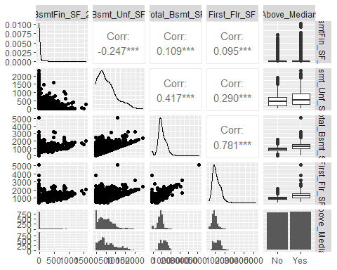

ggpairs(ames_salesClean, columns = c(45:47, 62, 82))

## `stat_bin()` using `bins = 30`. Pick better value with `binwidth`.  
## `stat_bin()` using `bins = 30`. Pick better value with `binwidth`.  
## `stat_bin()` using `bins = 30`. Pick better value with `binwidth`.  
## `stat_bin()` using `bins = 30`. Pick better value with `binwidth`.

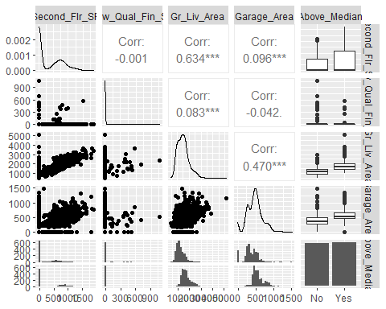

# ggpairs(ames_salesClean, columns = c(66:69, 82))  
# ggpairs(ames_salesClean, columns = c(70:71, 75, 80:82))  
  
# ggpairs(ames_salesClean, columns = c(48:52,82))  
# ggpairs(ames_salesClean, columns = c(53,55,57,61,82))

Decent correlation (0.781) between First_Flr_SF and Total_Bsmt_SF. Possible competing predictor variables. If both of these prove to be strong predictors of Above_Median.

h1 = ggplot(ames_salesClean, aes(x=Lot_Frontage))+  
 geom_histogram()  
h2 = ggplot(ames_salesClean, aes(x=Lot_Area))+  
 geom_histogram()  
h3 = ggplot(ames_salesClean, aes(x=Mas_Vnr_Area))+  
 geom_histogram()  
h4 = ggplot(ames_salesClean, aes(x=BsmtFin_SF_1))+  
 geom_histogram()  
h5 = ggplot(ames_salesClean, aes(x=BsmtFin_SF_2))+  
 geom_histogram()  
h6 = ggplot(ames_salesClean, aes(x=Bsmt_Unf_SF))+  
 geom_histogram()  
h7 = ggplot(ames_salesClean, aes(x=Total_Bsmt_SF))+  
 geom_histogram()  
h8 = ggplot(ames_salesClean, aes(x=First_Flr_SF))+  
 geom_histogram()  
h9 = ggplot(ames_salesClean, aes(x=Second_Flr_SF))+  
 geom_histogram()  
h10 = ggplot(ames_salesClean, aes(x=Low_Qual_Fin_SF))+  
 geom_histogram()  
h11 = ggplot(ames_salesClean, aes(x=Gr_Liv_Area))+  
 geom_histogram()  
h12 = ggplot(ames_salesClean, aes(x=Garage_Area))+  
 geom_histogram()  
h13 = ggplot(ames_salesClean, aes(x=Wood_Deck_SF))+  
 geom_histogram()  
h14 = ggplot(ames_salesClean, aes(x=Open_Porch_SF))+  
 geom_histogram()  
h15 = ggplot(ames_salesClean, aes(x=Enclosed_Porch))+  
 geom_histogram()  
h16 = ggplot(ames_salesClean, aes(x=Three_season_porch))+  
 geom_histogram()  
h17 = ggplot(ames_salesClean, aes(x=Screen_Porch))+  
 geom_histogram()  
h18 = ggplot(ames_salesClean, aes(x=Pool_Area))+  
 geom_histogram()  
h19 = ggplot(ames_salesClean, aes(x=Misc_Val))+  
 geom_histogram()  
h20 = ggplot(ames_salesClean, aes(x=Longitude))+  
 geom_histogram()  
h21 = ggplot(ames_salesClean, aes(x=Latitude))+  
 geom_histogram()  
  
grid.arrange(h1,h2,h3,h4,h5,h6,ncol=2)

## `stat_bin()` using `bins = 30`. Pick better value with `binwidth`.  
## `stat_bin()` using `bins = 30`. Pick better value with `binwidth`.  
## `stat_bin()` using `bins = 30`. Pick better value with `binwidth`.  
## `stat_bin()` using `bins = 30`. Pick better value with `binwidth`.  
## `stat_bin()` using `bins = 30`. Pick better value with `binwidth`.  
## `stat_bin()` using `bins = 30`. Pick better value with `binwidth`.

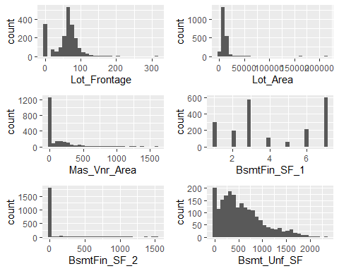

grid.arrange(h7,h8,h9,h10,h11,h12,ncol=2)

## `stat_bin()` using `bins = 30`. Pick better value with `binwidth`.  
## `stat_bin()` using `bins = 30`. Pick better value with `binwidth`.  
## `stat_bin()` using `bins = 30`. Pick better value with `binwidth`.  
## `stat_bin()` using `bins = 30`. Pick better value with `binwidth`.  
## `stat_bin()` using `bins = 30`. Pick better value with `binwidth`.  
## `stat_bin()` using `bins = 30`. Pick better value with `binwidth`.

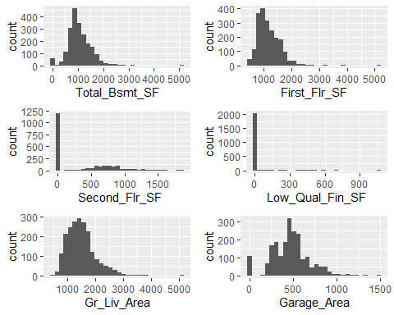

grid.arrange(h13,h14,h15,h16,h17,h18,ncol=2)

## `stat_bin()` using `bins = 30`. Pick better value with `binwidth`.  
## `stat_bin()` using `bins = 30`. Pick better value with `binwidth`.  
## `stat_bin()` using `bins = 30`. Pick better value with `binwidth`.  
## `stat_bin()` using `bins = 30`. Pick better value with `binwidth`.  
## `stat_bin()` using `bins = 30`. Pick better value with `binwidth`.  
## `stat_bin()` using `bins = 30`. Pick better value with `binwidth`.

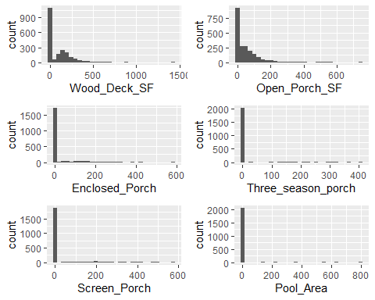

grid.arrange(h19,h20,h21, ncol=2)

## `stat_bin()` using `bins = 30`. Pick better value with `binwidth`.  
## `stat_bin()` using `bins = 30`. Pick better value with `binwidth`.  
## `stat_bin()` using `bins = 30`. Pick better value with `binwidth`.

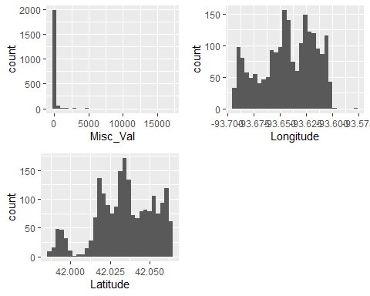

#Many of the Continuous variables have large amount of "o" observations.

Many of the continuous variables have most of their observations listed as 0. Eliminating these variables as possible predictors for Above_Median (would recommend removing these variables entirely from the data set).

Will look into Total_Bsmt_SF, First_FLr_SF,Gr_Liv_Area, Garage_Area, Lot Frontage, Bsmt_Fin_SF_1, BSmt_Unf_SF further as predictors of Above_Median as Box Plots.

pd1 = ggplot(ames_salesClean, aes(x=Year_Built_Group, fill = Above_Median)) +   
 geom_bar()  
pd2 = ggplot(ames_salesClean, aes(x=Year_RemodAdd_Group, fill = Above_Median)) +   
 geom_bar()  
pd3 = ggplot(ames_salesClean, aes(x=Bsmt_Full_Bath, fill = Above_Median)) +   
 geom_bar()  
pd4 = ggplot(ames_salesClean, aes(x=Bsmt_Half_Bath, fill = Above_Median)) +   
 geom_bar()  
pd5 = ggplot(ames_salesClean, aes(x=Bedroom_AbvGr, fill = Above_Median)) +   
 geom_bar()  
pd6 = ggplot(ames_salesClean, aes(x=Kitchen_AbvGr, fill = Above_Median)) +   
 geom_bar()  
pd7 = ggplot(ames_salesClean, aes(x=TotRms_AbvGrd, fill = Above_Median)) +   
 geom_bar()  
pd8 = ggplot(ames_salesClean, aes(x=Fireplaces, fill = Above_Median)) +  
 geom_bar()  
pd9 = ggplot(ames_salesClean, aes(x=Garage_Cars, fill = Above_Median)) +   
 geom_bar()  
pd10 = ggplot(ames_salesClean, aes(x=Mo_Sold, fill = Above_Median)) +   
 geom_bar()  
pd11 = ggplot(ames_salesClean, aes(x=Year_Sold, fill = Above_Median)) +   
 geom_bar()  
pd12 = ggplot(ames_salesClean, aes(x=Full_Bath, fill = Above_Median)) +   
 geom_bar()  
pd13 = ggplot(ames_salesClean, aes(x=Half_Bath, fill = Above_Median)) +   
 geom_bar()  
  
  
grid.arrange(pd1,pd2,pd3,pd4,ncol=2)

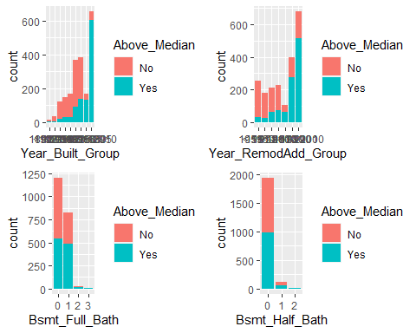

grid.arrange(pd5,pd6,pd7,pd8,ncol=2)

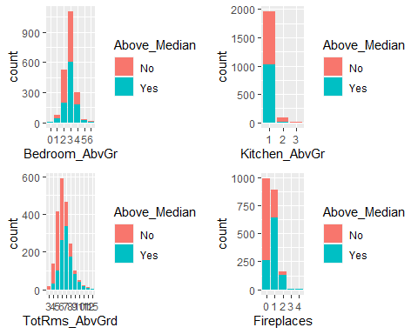

grid.arrange(pd9,pd10,pd11,pd12,pd13,ncol=2)

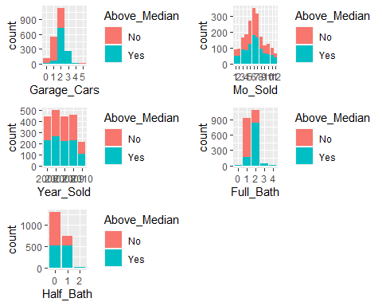

Will further explore Bedroom_AbvGr, TotalRms_AbvGrd, Fireplaces, Garage_Cars, & Full_Bath a little further as predictors.

All other variables in this group appear to have equally distributed observations of Yes and No across the different levels.

pn24 = ggplot(ames_salesClean, aes(x=MS_SubClass, fill = Above_Median))+  
 geom_bar()+  
 theme(axis.text.x = element_text(angle = 45, vjust = 1, hjust=1))  
pn25 = ggplot(ames_salesClean, aes(x=MS_Zoning, fill = Above_Median)) +  
 geom_bar()  
pn26 = ggplot(ames_salesClean, aes(x=Street, fill = Above_Median)) +  
 geom_bar()  
pn27 = ggplot(ames_salesClean, aes(x=Alley, fill = Above_Median)) +  
 geom_bar()  
pn28 = ggplot(ames_salesClean, aes(x=Land_Contour, fill = Above_Median)) +  
 geom_bar()  
pn29 = ggplot(ames_salesClean, aes(x=Lot_Config, fill = Above_Median)) +  
 geom_bar()  
pn30 = ggplot(ames_salesClean, aes(x=Neighborhood,fill = Above_Median)) +  
 geom_bar()  
pn31 = ggplot(ames_salesClean, aes(x=Condition_1, fill = Above_Median)) +  
 geom_bar()  
pn32 = ggplot(ames_salesClean, aes(x=Condition_2, fill = Above_Median)) +  
 geom_bar()  
pn33 = ggplot(ames_salesClean, aes(x=Bldg_Type, fill = Above_Median)) +  
 geom_bar()  
pn34 = ggplot(ames_salesClean, aes(x=House_Style, fill = Above_Median)) +  
 geom_bar()  
pn35 = ggplot(ames_salesClean, aes(x=Roof_Style, fill = Above_Median)) +  
 geom_bar()  
pn36 = ggplot(ames_salesClean, aes(x=Roof_Matl, fill = Above_Median)) +  
 geom_bar()  
pn37 = ggplot(ames_salesClean, aes(x=Exterior_1st, fill = Above_Median)) +  
 geom_bar()  
pn38 = ggplot(ames_salesClean, aes(x=Exterior_2nd, fill = Above_Median)) +  
 geom_bar()  
pn39 = ggplot(ames_salesClean, aes(x=Mas_Vnr_Area, fill = Above_Median)) +  
 geom_bar()  
pn40 = ggplot(ames_salesClean, aes(x=Foundation, fill = Above_Median)) +  
 geom_bar()  
pn41 = ggplot(ames_salesClean, aes(x=Heating, fill = Above_Median)) +  
 geom_bar()  
pn42 = ggplot(ames_salesClean, aes(x=Central_Air, fill = Above_Median)) +  
 geom_bar()  
pn43 = ggplot(ames_salesClean, aes(x=Garage_Type, fill = Above_Median)) +   
 geom_bar()  
pn44 = ggplot(ames_salesClean, aes(x=Misc_Feature, fill = Above_Median)) +   
 geom_bar()  
pn45 = ggplot(ames_salesClean, aes(x=Sale_Type, fill = Above_Median)) +   
 geom_bar()  
pn46 = ggplot(ames_salesClean, aes(x=Sale_Condition, fill = Above_Median)) +   
 geom_bar()  
  
  
# grid.arrange(pn24,pn25,pn26,pn27,pn28,ncol=2)  
# grid.arrange(pn29,pn30,pn31,pn32,ncol=2)  
# grid.arrange(pn33,pn34,pn35,pn36,ncol=2)  
# grid.arrange(pn37,pn38,pn39,pn40,ncol=2)  
# grid.arrange(pn41,pn42,pn43,pn44,ncol=2)  
# grid.arrange(pn45,pn46,ncol=2)

Just like the previous plots for the Discrete variables, many of these variables have a large portion of their observations sitting in one level. And of these that sit in this one level, the Above_Median response is evenly distributed for the most part.For the charts that do not have most of their observations sitting in one level, I expect to see a clear “winner” between “Yes” and “No” (Above_Median) in for each level(or the majority of the levels).

Will explore MS_SubClass, Lot_Config, Neighborhood, Exterior_1st, EXterior_2nd, and Garage_Type further.

po1 = ggplot(ames_salesClean, aes(x=Lot_Shape, fill = Above_Median)) +   
 geom_bar()  
po2 = ggplot(ames_salesClean, aes(x=Utilities, fill = Above_Median)) +   
 geom_bar()  
po3 = ggplot(ames_salesClean, aes(x=Land_Slope, fill = Above_Median)) +   
 geom_bar()  
po4 = ggplot(ames_salesClean, aes(x=Overall_Qual, fill = Above_Median)) +   
 geom_bar()+  
 xlab("Overall Quality")+  
 ylab("Count of Sales")+  
 labs(fill = "Above Median")+  
 theme(axis.text.x = element_text(angle = 45, vjust = 1, hjust=1))+  
 scale_fill_brewer(palette = "Set2")  
po5 = ggplot(ames_salesClean, aes(x=Overall_Cond, fill = Above_Median)) +   
 geom_bar()  
po6 = ggplot(ames_salesClean, aes(x=Exter_Qual, fill = Above_Median)) +   
 geom_bar()  
po7 = ggplot(ames_salesClean, aes(x=Exter_Cond, fill = Above_Median)) +   
 geom_bar()  
po8 = ggplot(ames_salesClean, aes(x=Bsmt_Qual, fill = Above_Median)) +   
 geom_bar()  
po9 = ggplot(ames_salesClean, aes(x=Bsmt_Cond, fill = Above_Median)) +   
 geom_bar()  
po10 = ggplot(ames_salesClean, aes(x=Bsmt_Exposure, fill = Above_Median)) +   
 geom_bar()  
po11 = ggplot(ames_salesClean, aes(x=BsmtFin_Type_1, fill = Above_Median)) +   
 geom_bar()  
po12 = ggplot(ames_salesClean, aes(x=BsmtFin_Type_2, fill = Above_Median)) +   
 geom_bar()  
po13 = ggplot(ames_salesClean, aes(x=Heating_QC, fill = Above_Median)) +   
 geom_bar()  
po14 = ggplot(ames_salesClean, aes(x=Electrical, fill = Above_Median)) +   
 geom_bar()  
po15 = ggplot(ames_salesClean, aes(x=Kitchen_Qual, fill = Above_Median)) +   
 geom_bar()  
po16 = ggplot(ames_salesClean, aes(x=Functional, fill = Above_Median)) +   
 geom_bar()+  
 xlab("Functional")+  
 ylab("Count of Sales")+  
 labs(fill = "Above Median")+  
 theme(axis.text.x = element_text(angle = 45, vjust = 1, hjust=1))+  
 scale_fill_brewer(palette = "Set2")  
po17 = ggplot(ames_salesClean, aes(x=Fireplace_Qu, fill = Above_Median)) +   
 geom_bar()  
po18 = ggplot(ames_salesClean, aes(x=Garage_Finish, fill = Above_Median)) +   
 geom_bar()  
po19 = ggplot(ames_salesClean, aes(x=Garage_Qual, fill = Above_Median)) +   
 geom_bar()  
po20 = ggplot(ames_salesClean, aes(x=Garage_Cond, fill = Above_Median)) +   
 geom_bar()  
po21 = ggplot(ames_salesClean, aes(x=Paved_Drive, fill = Above_Median)) +   
 geom_bar()  
po22 = ggplot(ames_salesClean, aes(x=Pool_QC, fill = Above_Median)) + geom_bar()  
po23 = ggplot(ames_salesClean, aes(x=Fence, fill = Above_Median)) + geom_bar()  
  
  
  
# grid.arrange(po1,po2,po3,po4,ncol=2)  
# grid.arrange(po5,po6,po7,po8,ncol=2)  
# grid.arrange(po9,po10,po11,po12,ncol=2)  
# grid.arrange(po13,po14,po15,po16,ncol=2)  
# grid.arrange(po17,po18,po19,po20,ncol=2)  
# grid.arrange(po21,po22,po23,ncol=2)

Just like the other variable types, there are variables that have a large portion of their observations sitting in one level. And of these that sit in this one level, the Above_Median response is evenly distributed for the most part.

For the charts that do not have most of their observations sitting in one level, I expect to see a pattern e.g. “Yes” proportion of responses clearly increases or decreases from left to right since these are ordinal variables.

Will explore Lot_Shape, Overall_Qual, Overall_Cond, Exter_qual, Bsmt_Qual, Bsmt_Exposure_, BsmtFin_Type_1, Heating_QC, KItchen_Qual, Fireplace_Qu, Grage_Finish further.

b1 = ggplot(ames_salesClean, aes(x=Above_Median, y=Lot_Frontage))+  
 geom_boxplot()  
b2 = ggplot(ames_salesClean, aes(x=Above_Median, y=BsmtFin_SF_1))+  
 geom_boxplot()  
b3 = ggplot(ames_salesClean, aes(x=Above_Median, y=Bsmt_Unf_SF))+  
 geom_boxplot()  
b4 = ggplot(ames_salesClean, aes(x=Above_Median, y=Total_Bsmt_SF, fill=Above_Median))+  
 geom_boxplot()+  
 xlab("Above Median")+  
 ylab("Basement Area (sq ft)")+  
 scale_fill_brewer(palette = "Set2")  
b5 = ggplot(ames_salesClean, aes(x=Above_Median, y=First_Flr_SF,   
 fill=Above_Median))+  
 geom_boxplot()+  
 xlab("Above Median")+  
 ylab("1st Floor Area (sq ft)")+  
 scale_fill_brewer(palette = "Set2")  
b6 = ggplot(ames_salesClean, aes(x=Above_Median, y=Gr_Liv_Area,  
 fill=Above_Median))+  
 geom_boxplot()+  
 xlab("Above Median")+  
 ylab("Ground Living Area (sq ft)")+  
 scale_fill_brewer(palette = "Set2")  
b7 = ggplot(ames_salesClean, aes(x=Above_Median, y=Garage_Area, fill=Above_Median))+  
 geom_boxplot()+  
 xlab("Above Median")+  
 ylab("Garage Area (sq ft)")+  
 scale_fill_brewer(palette = "Set2")  
  
b8 = ggplot(ames_salesClean, aes(x=Above_Median, y=Latitude))+  
 geom_boxplot()  
b9 = ggplot(ames_salesClean, aes(x=Above_Median, y=Longitude))+  
 geom_boxplot()  
  
grid.arrange(b1,b2,b3,ncol=2)

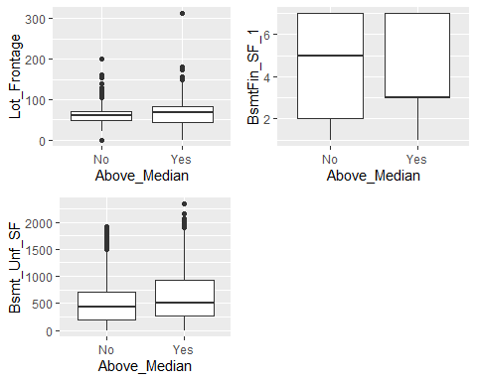

grid.arrange(b4,b5,b6,b7, ncol=2)

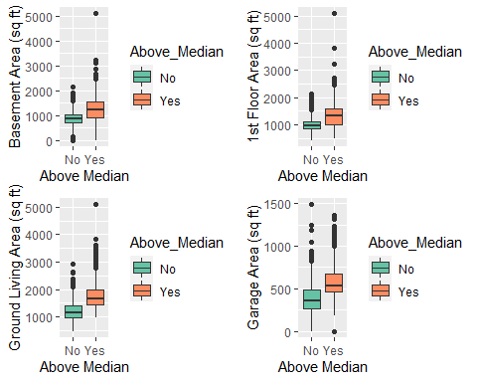 Continuous variables that had a pretty nice looking histogram; Will explore Total_Bsmt_SF, First_Flr_SF, Gr_LIv_Area, and Garage_Area a little further as scatter plots.

I am on the fence on exploring Latitude and Longitude further, since I believe these two will be closely related to the Neighborhood variable.

ggpairs(ames_salesClean, columns = c(39, 44, 47, 62, 82))

## `stat_bin()` using `bins = 30`. Pick better value with `binwidth`.  
## `stat_bin()` using `bins = 30`. Pick better value with `binwidth`.  
## `stat_bin()` using `bins = 30`. Pick better value with `binwidth`.  
## `stat_bin()` using `bins = 30`. Pick better value with `binwidth`.

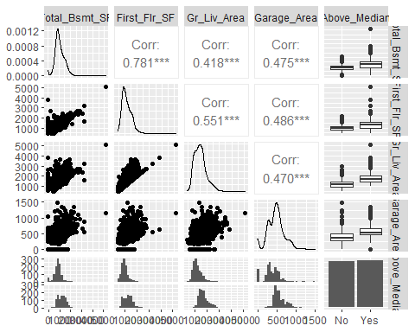

#Note: there is a 0.781 correlation between First_Flr_SF and Total_Bsmt_SF

Continuous variables that had a pretty nice looking histogram; Will explore Total_Bsmt_SF, First_Flr_SF, Gr_LIv_Area, and Garage_Area a little further as scatter plots.

I am on the fence on exploring Latitude and Longitude further, since I believe these two will be closely related to the Neighborhood variable.

ggpairs(ames_salesClean, columns = c(39, 44, 47, 62, 82))

## `stat_bin()` using `bins = 30`. Pick better value with `binwidth`.  
## `stat_bin()` using `bins = 30`. Pick better value with `binwidth`.  
## `stat_bin()` using `bins = 30`. Pick better value with `binwidth`.  
## `stat_bin()` using `bins = 30`. Pick better value with `binwidth`.



#Note: there is a 0.781 correlation between First_Flr_SF and Total_Bsmt_SF

Using ggpairs again to explore First_Flr_SF, Gr_Liv_Area, Garage_Area, and Total_Bsmt_SF as predictors for Above_Median.

ggplot(ames_salesClean, aes(x=Gr_Liv_Area, y=X1,color=Above_Median))+  
 geom_point()+  
 xlab("Ground Living Area - Above Grade (sq ft)") + ylab("Count of Sales")+  
 labs(fill = "Above Median")+  
 scale_color_brewer(palette = "Set2")

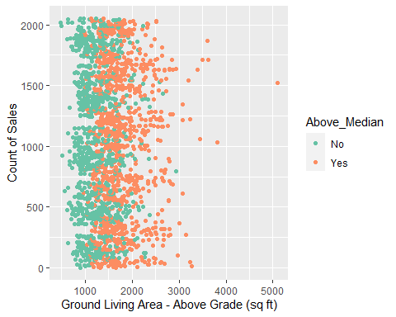

# ggplot(ames_salesClean, aes(x=First_Flr_SF, y=X1,  
# color=Above_Median))+geom_point()  
  
ggplot(ames_salesClean, aes(x=Total_Bsmt_SF, y=First_Flr_SF, color = Above_Median))+  
 geom_point()+  
 xlab("Basement Area (sq ft)") + ylab("1st Floor (sq ft)")+  
 labs(fill = "Above Median")+  
 theme(axis.text.x = element_text(angle = 46, vjust = 1, hjust=1))+  
 facet_wrap(~ Year_RemodAdd_Group)+  
 scale_color_brewer(palette = "Set2")

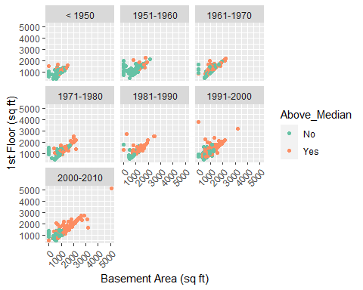

# ggplot(ames_salesClean, aes(x=Year_Remod_Add, y=First_Flr_SF, color = Above_Median))+  
# geom_point()+  
# theme(axis.text.x = element_text(angle = 46, vjust = 1, hjust=1))+  
# facet_wrap(~ Overall_Qual)

Taking a deeper look into the 0.781 correlation between First Floor and Total Basement variables. Both of these variables, when created as Box Plots against Above_Median, warrant a closer analysis

Although “Yes” observations tend to lean towards the higher BSmt SF and First Floor SF, there is still some overlapping, however, broken out by Year RemodAdd Group

p1 = ggplot(ames_salesClean, aes(x=Lot_Shape, fill = Above_Median)) +   
 geom_bar(position="fill")  
p2 = ggplot(ames_salesClean, aes(x=Lot_Config, fill = Above_Median)) +   
 geom_bar(position="fill")  
p3 = ggplot(ames_salesClean, aes(x=Overall_Qual, fill = Above_Median)) +   
 geom_bar(position="fill")+  
 xlab("Overall Quality") +  
 labs(fill = "Above Median")+  
 theme(axis.text.x = element_text(angle = 46, vjust = 1, hjust=1))  
p4 = ggplot(ames_salesClean, aes(x=Overall_Cond, fill = Above_Median)) +   
 geom_bar(position="fill")  
p5 = ggplot(ames_salesClean, aes(x=Bsmt_Qual, fill = Above_Median)) +   
 geom_bar(position="fill")  
p6 = ggplot(ames_salesClean, aes(x=Bsmt_Exposure, fill = Above_Median)) +   
 geom_bar(position="fill")  
p7 = ggplot(ames_salesClean, aes(x=BsmtFin_Type_1, fill = Above_Median)) +   
 geom_bar(position="fill")  
p8 = ggplot(ames_salesClean, aes(x=Heating_QC, fill = Above_Median)) +   
 geom_bar(position="fill")  
p9 = ggplot(ames_salesClean, aes(x=Kitchen_Qual, fill = Above_Median)) +   
 geom_bar(position="fill")  
p10 = ggplot(ames_salesClean, aes(x=Garage_Finish, fill = Above_Median)) +   
 geom_bar(position="fill")  
p11 = ggplot(ames_salesClean, aes(x=Neighborhood, fill = Above_Median)) +  
 geom_bar(position="fill")+  
 ylab("Count of Sales")+  
 labs(fill = "Above Median")+  
 theme(axis.text.x = element_text(angle = 90, vjust = 1, hjust=1))+  
 scale_fill_brewer(palette = "Set2")  
p12 = ggplot(ames_salesClean, aes(x=Exterior_1st, fill = Above_Median)) +  
 geom_bar(position="fill")  
p13 = ggplot(ames_salesClean, aes(x=Exterior_2nd, fill = Above_Median)) +  
 geom_bar(position="fill")  
p14 = ggplot(ames_salesClean, aes(x=Bedroom_AbvGr, fill = Above_Median)) +   
 geom_bar()+  
 ylab("Count of Sales")+  
 labs(fill = "Above Median")+  
 scale_fill_brewer(palette = "Set2")+  
 facet_wrap(~ Year_RemodAdd_Group)  
p15 = ggplot(ames_salesClean, aes(x=TotRms_AbvGrd, fill = Above_Median)) +   
 geom_bar(position="fill")  
p16 = ggplot(ames_salesClean, aes(x=Fireplaces, fill = Above_Median)) +   
 geom_bar(position="fill")  
p17 = ggplot(ames_salesClean, aes(x=Fireplace_Qu, fill = Above_Median)) +   
 geom_bar(position="fill")  
p18 = ggplot(ames_salesClean, aes(x=Garage_Type, fill = Above_Median)) +   
 geom_bar(position="fill")  
p19 = ggplot(ames_salesClean, aes(x=Garage_Cars, fill = Above_Median)) +   
 geom_bar(position="fill")  
p20 = ggplot(ames_salesClean, aes(x=Exter_Qual, fill = Above_Median)) +   
 geom_bar(position="fill")  
p21 = ggplot(ames_salesClean, aes(x=Year_Built_Group, fill = Above_Median)) +   
 geom_bar(position="fill")  
p22 = ggplot(ames_salesClean, aes(x=Year_RemodAdd_Group, fill = Above_Median)) +  
 geom_bar(position="fill")  
p23 = ggplot(ames_salesClean, aes(x=Full_Bath, fill = Above_Median)) +   
 geom_bar(position="fill")  
p24 = ggplot(ames_salesClean, aes(x=MS_SubClass, fill = Above_Median)) +   
 geom_bar(position="fill")  
  
  
# grid.arrange(p1,p2,p3,p4,ncol=2)  
# grid.arrange(p5,p6,p7,p8,ncol=2)  
# grid.arrange(p9,p10,p11,p12,ncol=2)  
# grid.arrange(p13,p14,p15,p16,ncol=2)  
# grid.arrange(p17,p18,p19,p20,ncol=2)  
# grid.arrange(p21,p22,p23,p24,ncol=2)

Remove Lot_Config, Exterior_2nd, Bedroom_AbvGr, Overall_Cond, and BSmtFin_Type1 from further analysis as strong predictor variables for Above_Median.

Viewing a filled bar graph for these variables make it a little more clear that the “Yes” and “No” variables are more evenly distributed across the levels, not good for predicting.

# ames_salesClean %>% count(First_Flr_SF)  
# ames_salesClean %>% count(Gr_Liv_Area)  
# ames_salesClean %>% count(Garage_Area)  
# ames_salesClean %>% count(Total_Bsmt_SF)

Removing Garage_Area and Total_Bsmt_SF as strong predictors due to the 0 sqf observations.

grid.arrange(b5,h8,b6,h11,ncol=2)

## `stat_bin()` using `bins = 30`. Pick better value with `binwidth`.  
## `stat_bin()` using `bins = 30`. Pick better value with `binwidth`.

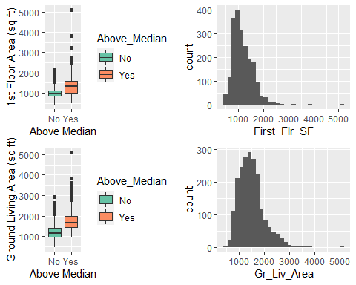

# p22  
# p15  
p11

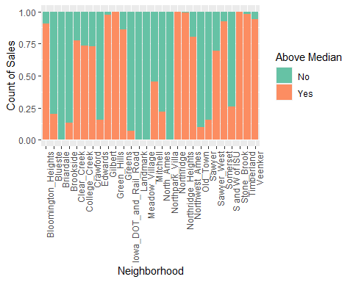

# p1  
po4

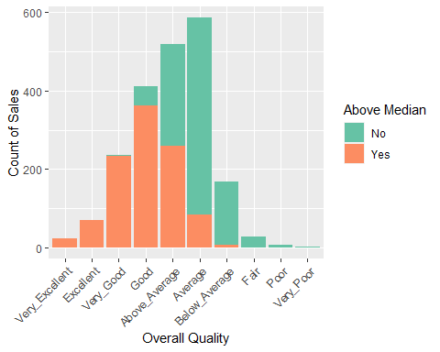

# p3  
# p20  
# p9  
# p10  
b4

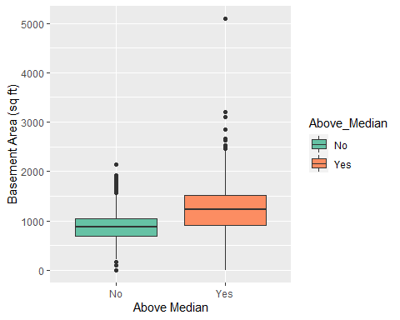

p14

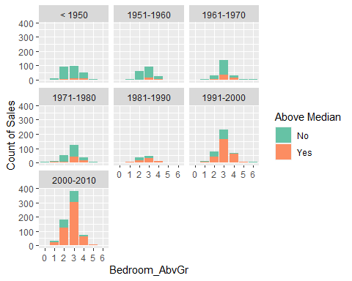

po16

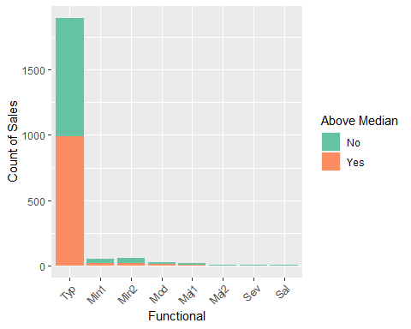

# grid.arrange(b7,h12, b4,h7, ncol=2)  
#   
# p21  
# p16  
# p19  
# p23  
# p18  
# p5  
# p8  
# p17